## A Faster Way to Save Signs (Right Click > Save)

RapidPlan has a much faster and easier way to save signs when you don’t need to save and edit different variations.

Using **Save** from the context menu allows you to save a group as a sign to the **Custom** tab of the Signs Palette. It is a simple process, but doesn’t afford the power or flexibility that the Sign Editor allows.

In some regards, it is the “lazy man’s” sign creation tool - but it is equally suited to less sophisticated users who don’t need or are unable to create signs using the full sign creation process.

**How to Save from the context menu:**

* Ensure all of the elements of your sign are **grouped**.
* Right click on the group and select **Save** from the context menu that appears.
* 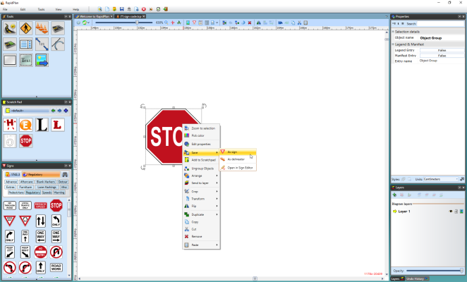
* Saving_a_Sign_from_the_Context_Menu
* In this save option you can enter a name for the sign, a sign code and a description. You can also select whether to save it to the **Custom** tab or to a file.
* 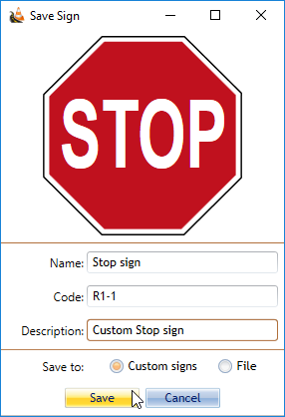
* Save_Sign_Option